**Aim:** Implement Dynamic Routing algorithms.

1. **Routing Information Protocol (RIP) :**

The Routing Information Protocol (RIP) defines a way for [routers](https://searchnetworking.techtarget.com/definition/router), which connect networks using the Internet Protocol (IP), to share information about how to route traffic among networks.

Each RIP router maintains a routing table, which is a list of all the destinations (networks) it knows how to reach, along with the distance to that destination. RIP uses a distance vector algorithm to decide which path to put a packet on to get to its destination. It stores in its routing table the distance for each network it knows how to reach, along with the address of the "next hop" router -- another router that is on one of the same networks -- through which a packet has to travel to get to that destination. If it receives an update on a route, and the new path is shorter, it will update its table entry with the length and next-hop address of the shorter path; if the new path is longer, it will wait through a "hold-down" period to see if later updates reflect the higher value as well, and only update the table entry if the new, longer path is stable.

**Implement RIP in Cisco Packet Tracer**

1. Create a Network in Cisco Packet Tracer

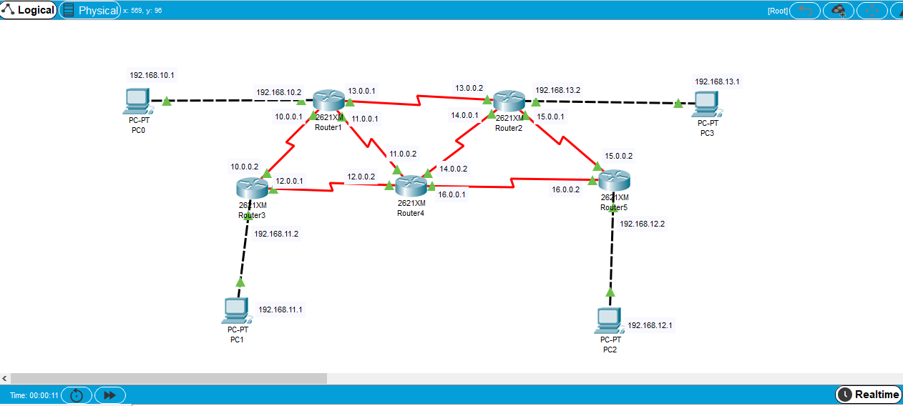

1. Give IP configuration to all Hosts

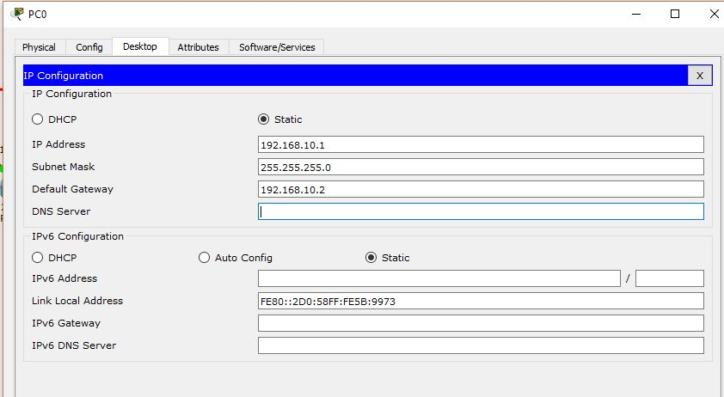

1. Give IP Configuration to all interfaces of all routers

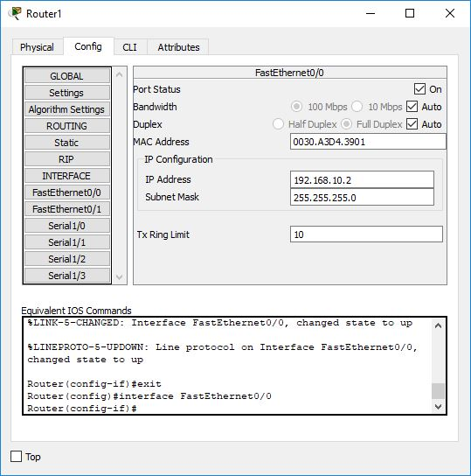

1. Make an entry in routing table in each router CLI for routing.
   1. Router rip
   2. Network <NID>

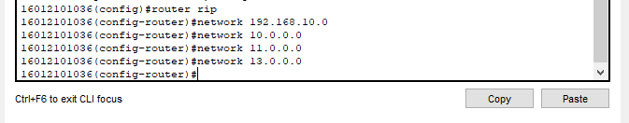

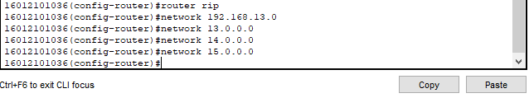

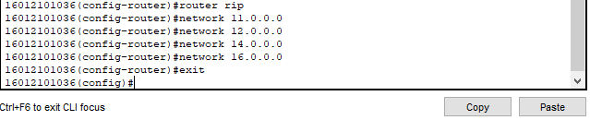

1. Send the message and test it.

